**石家庄铁道大学信息科学与技术学院**

**实习报告**

**2019年----2020年 第一学期**

专 业： 软件工程

课程名称： 软件工程综合实践

班 级： 信1605-1班

姓 名： 王莉 学号：20163623

指导教师： 王建民

# 实验2-3 Kettle实现源数据的预处理

## 1.销售信息表去重，并去掉空格以及特殊字符

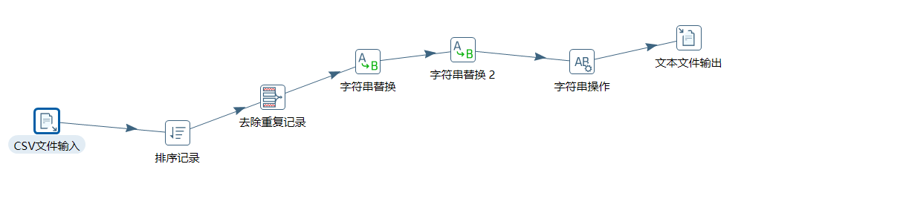

## 2.用户评论信息表去重

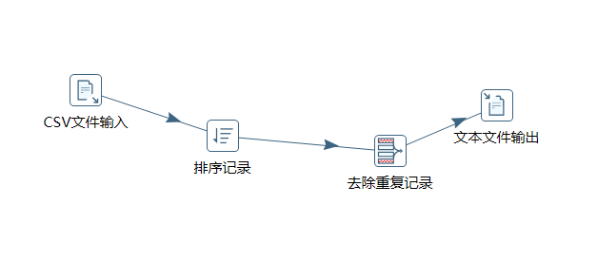

## 3.用户信息表出生日期字段转换

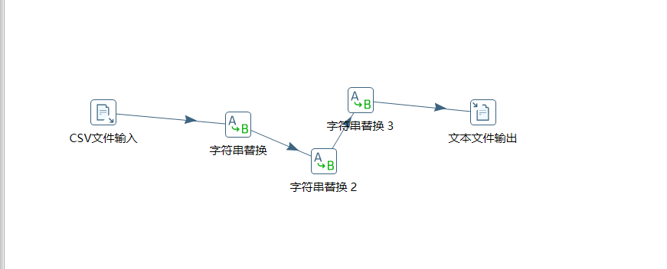

# 实验3-1 Hive加载电商源数据

## 创建表

### 1.1.创建用户基本信息表 userinfo

create table userinfo( userId string,userName string,userLocation string,sex string,birthday string)

ROW FORMAT DELIMITED FIELDS TERMINATED BY '\t';

load data local inpath '/usr/local/hive/userinfo.txt' into table userinfo;

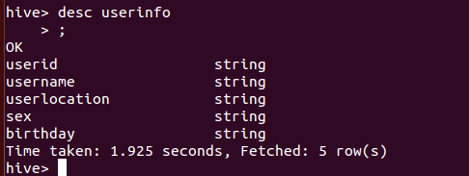

### 1.2.创建手机销售信息表 saleinfo

create table saleinfo(goodId string,goodName string,basicAttribute string,

shopName string,shopId string,goodUrl string,price double,keywords string, views string,goodviews string,grand string,type string,phoneColor string, timeToMarket string,operating string)

ROW FORMAT DELIMITED FIELDS TERMINATED BY '\t';

load data local inpath '/usr/local/hive/iphone.txt' into table saleinfo;

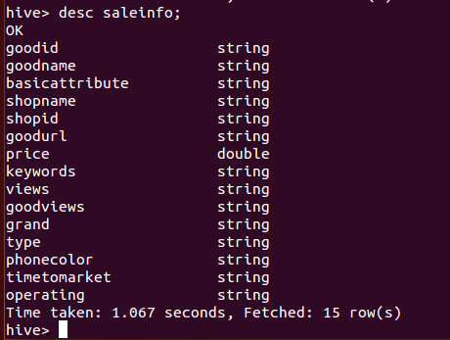

### 1.3.创建用户评价表 evaluation

create table evaluation(goodId string,comment string,postTime string,userId int,userName string,userGrade string,goodColor string,replyNum int,commentGrade int,sources string) row format delimited fields terminated by '\t';

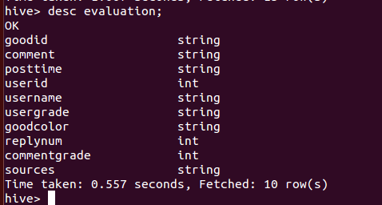

### 1.4.用户行为表 useraction

create table useraction(userId string,goodId string,action string,dealMonth string,dealDay string) row format delimited fields terminated by '\t';

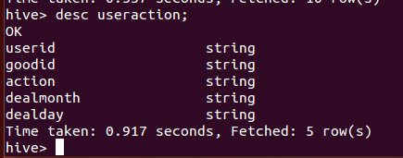

## 2．处理手机销售信息表数据

create table saledata(goodId string,goodName string,basicAttribute string,

shopName string,shopId string,goodUrl string,price double,keywords string, views string,goodviews string,grand string,type string,phoneColor string, timeToMarket string,operating string)

//创建新的saledata表

ROW FORMAT DELIMITED FIELDS TERMINATED BY '\t';

alter table saleinfo set serdeproperties('serialization.null.format' = '');

//将saleinfo表中没有数值的地方设为空

INSERT OVERWRITE TABLE saledata

select * FROM saleinfo where operating !=' ';

//查询出operating（操作系统）不为空的数据储存到saledata表中

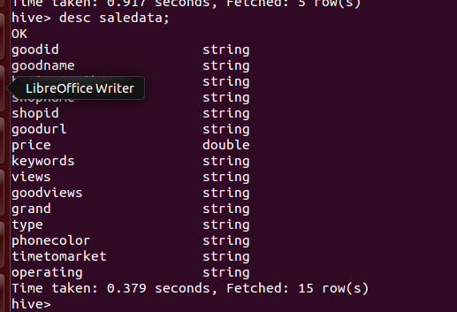

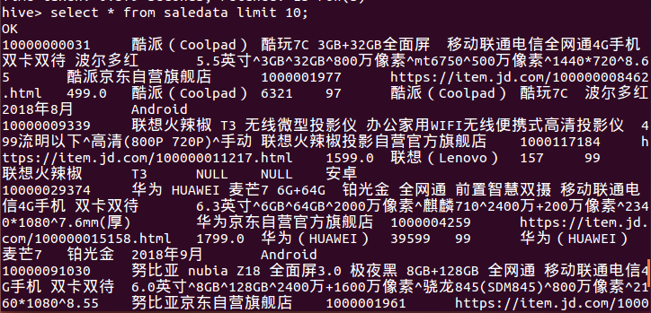

## 3. 处理用户行为表数据

create table useraction_new(userId string,goodId string,action string,dealTime string) row format delimited fields terminated by '\t';

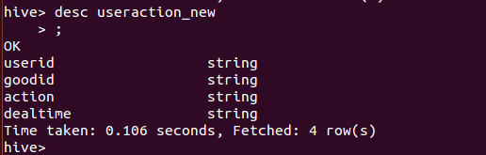

Insert overwrite table useraction_new select userId,goodId,action,concat (dealMonth,'-',dealDay) from useraction;

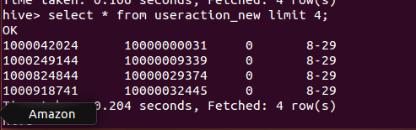

## 4. 处理用户信息表数据

create table userinfo_new(userId string,userName string,userlocation string,gender string,age_region string,age_region_alias string,usergrade string) row format delimited fields terminated by '\t';

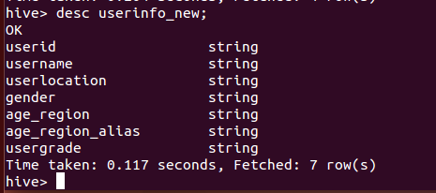

insert into userinfo_new select u.userId,u.userName,u.userLocation,u.sex,1 as age_region,'18岁以下' as age_region_alias,c.userGrade from userinfo u join evaluation c on u.userId=c.userId where year(u.birthday)>2001;

insert into userinfo_new select u.userId,u.userName,u.userLocation,u.sex,2 as age_region,'24岁以下' as age_region_alias,c.userGrade from userinfo u join evaluation c on u.userId=c.userId where year(u.birthday)<2001 and year(u.birthday)>1995;

insert into userinfo_new select u.userId,u.userName,u.userLocation,u.sex,3 as age_region,'29岁以下' as age_region_alias,c.userGrade from userinfo u join evaluation c on u.userId=c.userId where year(u.birthday)<1994 and year(u.birthday)>1990;

insert into userinfo_new select u.userId,u.userName,u.userLocation,u.sex,4 as age_region,'34岁以下' as age_region_alias,c.userGrade from userinfo u join evaluation c on u.userId=c.userId where year(u.birthday)<1989 and year(u.birthday)>1985;

insert into userinfo_new select u.userId,u.userName,u.userLocation,u.sex,5 as age_region,'39岁以下' as age_region_alias,c.userGrade from userinfo u join evaluation c on u.userId=c.userId where year(u.birthday)<1983 and year(u.birthday)>1980;

insert into userinfo_new select u.userId,u.userName,u.userLocation,u.sex,6 as age_region,'49岁以下' as age_region_alias,c.userGrade from userinfo u join evaluation c on u.userId=c.userId where year(u.birthday)<1978 and year(u.birthday)>1970;

insert into userinfo_new select u.userId,u.userName,u.userLocation,u.sex,7 as age_region,'50岁以上' as age_region_alias,c.userGrade from userinfo u join evaluation c on u.userId=c.userId where year(u.birthday)<1969;

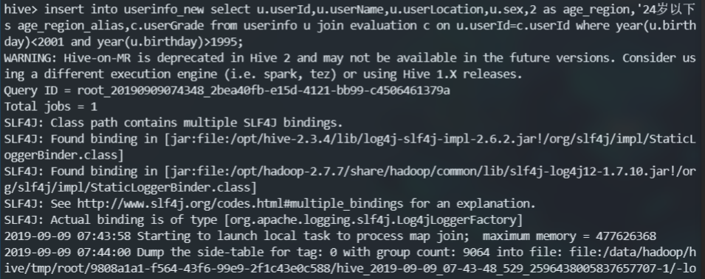

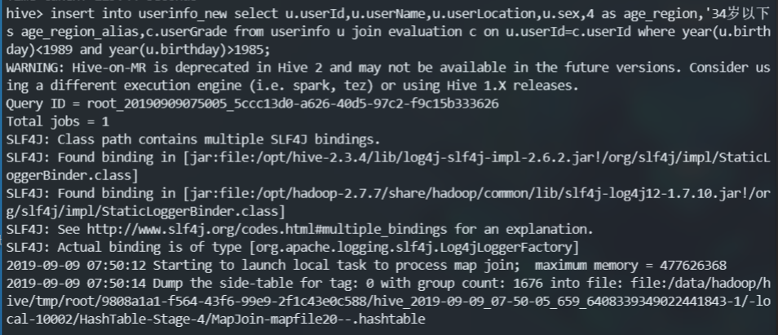

# 实验3-2 基于Spark构建用户画像

## 创建表

### 1.1 建立用户画像-用户属性标签表

 create table person_user_tag_attribute(

    tag_id string comment'标签 id',

  tag_name string,

    tag_type string

    )

row format delimited fields terminated by '/t' ;

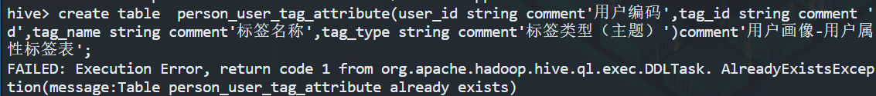

### 1.2 建立用户性别标签表

create table profile_tag_user_gender

(

user_id string comment'用户编码',

tag_id string comment'标签 id',

tag_name string comment'标签名称',

tag_type string comment'标签类型（主题）'

)

comment'用户画像-用户性别标签表';

row format delimited fields terminated by '/t' ;

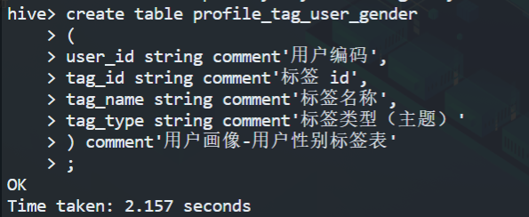

### 1.3 新建用户年龄段标签表

create table profile_tag_age_region

(

user_id string comment'用户编码',

tag_id string comment '标签 id',

tag_name string comment'标签名称',

tag_type string comment'标签类型（主题）'

)

comment'用户画像-用户年龄段标签表'

row format delimited fields terminated by '/t' ;

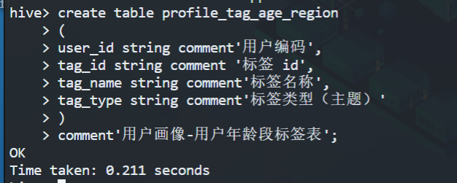

### 1.4 新建用户画像-用户会员标签表

create table profile_tag_user_grade

(

user_id string comment'用户编码',

tag_id string comment'标签 id',

tag_name string comment'标签名称',

tag_type string comment'标签类型（主题）'

)

comment'用户画像-用户会员标签表'

row format delimited fields terminated by '/t';

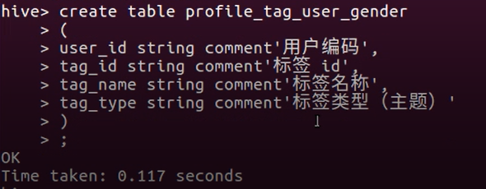

### 5 建立用户画像-用户行为标签表

create table profile_tag_action

(

user_id string comment'用户编码',

tag_id string comment'标签 id',

tag_name string comment'标签名称',

tag_type string comment'标签类型（主题）',

action_count int comment'行为次数'

)

comment'用户画像-用户行为标签表'

row format delimited fields terminated by '/t';

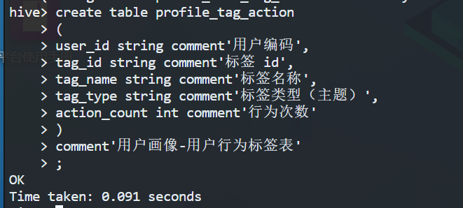

## 2.插入数据

共有四种标签：用户行为，用户性别，用户年龄，用户会员标签分别为A001U001,A001U002,A001U003, A001U004来标识。

用户行为：共有4种：0，1，2，3，标签id分别标为：A001U001_001, A001U001_002, A001U001_003, A001U001_004

用户性别：共有2种：男，女，标签id分别标为：A001U002_001, A001U002_002

用户年龄段：共有7段：年龄<18， [18,24] ，[25,29] ，[30,34]， [35,39] ，[40,49]，年龄>=50， 标签id分别为：A001U003_001，A001U003_002，A001U003_003，A001U003_004，A001U003_005，A001U003_006，A001U003_007.

用户会员：共有5种：铜牌会员，银牌会员，金牌会员，钻石会员，PLUS会员。标签id分别标为：A001U004_001, A001U004_002, A001U004_003, A001U004_004, A001U004_005

### 2.1 插入用户画像-用户行为标签表

将数据从useraction表查询出来插入用户画像-用户行为标签表.

插入语句：

insert into table profile_tag_action select userid user_id, "A001U001_001" tag_id, action  tag_name,"用户行为" tag_type,count(*)  action_count  from useraction  where action="0" group by userid,action;

insert into table profile_tag_action select userid user_id ,"A001U001_002" tag_id, action  tag_name,"用户行为" tag_type,

count(*)  action_count  from useraction  where action="1" group by

userid,action;

insert into table profile_tag_action select userid

user_id ,"A001U001_003" tag_id, action  tag_name,"用户行为" tag_type,

count(*)  action_count  from useraction  where action="2" group by

userid,action;

insert into table profile_tag_action select userid

user_id ,"A001U001_004" tag_id, action  tag_name,"用户行为" tag_type,

count(*)  action_count  from useraction  where action="3" group by

userid,action;

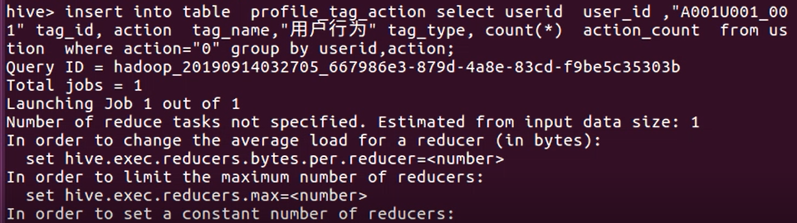

### 2.2 插入用户画像-用户性别标签表

insert into table  profile_tag_user_gender

select  userid  user_id,"A001U002_002" tag_id, sex  tag_name ,"用户性别" tag_type  from userinfo  where sex="女"

group by userid,sex;

insert into table  profile_tag_user_gender

select userid  user_id,"A001U002_001"

tag_id, sex  tag_name ,"用户性别" tag_type  from userinfo  where sex="男";

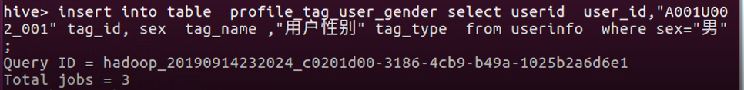

### 2.3 插入用户画像-用户年龄标签表

insert into table profile_tag_age_region

select  userid user_id,"A001U003_001" tag_id, age_region_alias  tag_name ,"用户年龄段" tag_type  from userinfo_new

where age_region=1 group by userid, age_region_alias;

insert into table  profile_tag_age_region

select  userid  user_id,"A001U003_002" tag_id, age_region_alias  tag_name ,"用户年龄段" tag_type  from userinfo_new  where age_region=2 group by userid, age_region_alias;

insert into table  profile_tag_age_region

select  userid  user_id,"A001U003_003" tag_id, age_region_alias  tag_name ,"用户年龄段" tag_type  from userinfo_new  where age_region=3 group by userid, age_region_alias;

insert into table  profile_tag_age_region

select  userid  user_id,"A001U003_004" tag_id, age_region_alias  tag_name ,"用户年龄段" tag_type  from userinfo_new  where age_region=4 group by userid, age_region_alias;

insert into table  profile_tag_age_region

select  userid  user_id,"A001U003_005" tag_id, age_region_alias  tag_name ,"用户年龄段" tag_type  from userinfo_new  where age_region=5 group by userid, age_region_alias;

insert into table  profile_tag_age_region

select  userid  user_id,"A001U003_006" tag_id, age_region_alias  tag_name ,"用户年龄段" tag_type  from userinfo_new  where age_region=6 group by userid, age_region_alias;

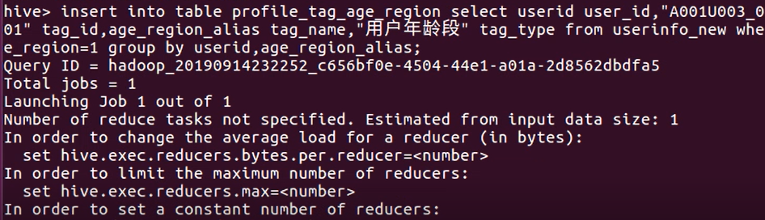

### 2.4 插入用户画像-用户会员标签表

insert into table  profile_tag_user_grade select  userid

user_id,"A001U004_001" tag_id,usergrade  tag_name ,"用户等级" tag_type  from  userinfo_new where usergrade="铜牌会员"

group by userid, usergrade;

insert into table  profile_tag_user_grade select  userid

user_id,"A001U004_002" tag_id,usergrade  tag_name ,"用户等级" tag_type  from  userinfo_new where usergrade="银牌会员"

group by userid, usergrade;

insert into table  profile_tag_user_grade select  userid

user_id,"A001U004_003" tag_id,usergrade  tag_name ,"用户等级" tag_type  from  userinfo_new where usergrade="金牌会员"

group by userid, usergrade;

insert into table  profile_tag_user_grade select  userid

user_id,"A001U004_004" tag_id,usergrade  tag_name ,"用户等级" tag_type  from  userinfo_new where usergrade="钻石会员"

group by userid, usergrade;

insert into table  profile_tag_user_grade select  userid

user_id,"A001U004_005" tag_id,usergrade  tag_name ,"用户等级" tag_type  from  userinfo_new where usergrade="PLUS会员"

group by userid, usergrade;

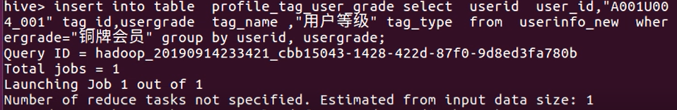

### 2.5 插入用户画像-用户属性标签表

load data local inpath "/data/用户精准画像标签2.txt" into table person_user_tag_attribute

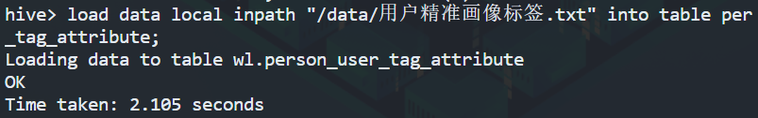

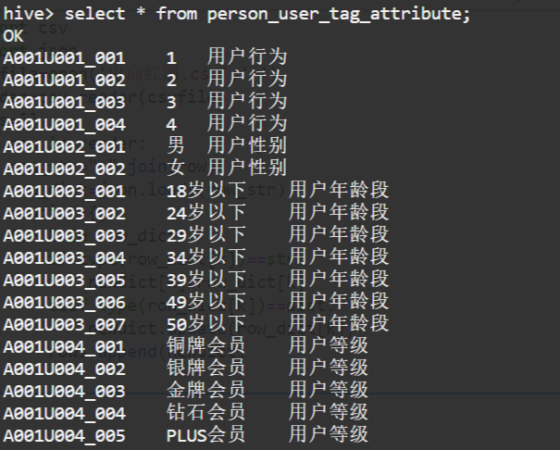

# 实验 4-1单品销售分析

## 1.基于手机销售新表，统计各手机品牌销量Top10

create table iphone_sail_top10(brand string,scount bigint)

ROW FORMAT DELIMITED FIELDS TERMINATED BY '\t';

INSERT OVERWRITE TABLE iphone_sail_top10

select grand,hot

from(

select

grand,

count(*) hot

from saledata GROUP BY grand

)t1

order by

hot DESC;

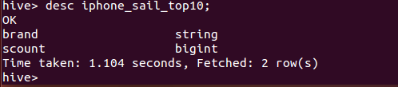

## 2.统计某品牌的各型号手机的销量

create table huawei_model_sail_info(_c0 string,mcount bigint)

ROW FORMAT DELIMITED FIELDS TERMINATED BY '\t';

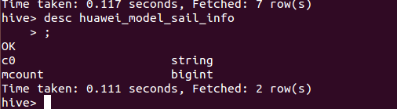

INSERT OVERWRITE TABLE huawei_model_sail_info

select type,hot

from(

select type,count(*) hot

from saledata where grand="华为（HUAWEI）"

GROUP BY type

)t2

order by

hot DESC

LIMIT 20;

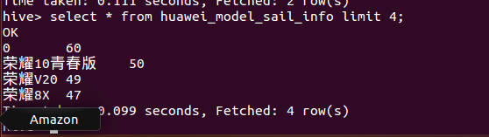

//苹果Top20

create table iphone_model_sail_info(model string,mcount bigint)

ROW FORMAT DELIMITED FIELDS TERMINATED BY '\t';

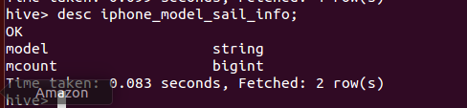

INSERT OVERWRITE TABLE iphone_model_sail_info

select type,hot

from(

select type,count(*) hot

from saledata where grand like "%Apple%" or grand like "%苹果%"

GROUP BY type

)t2

order by

hot DESC

LIMIT 20;

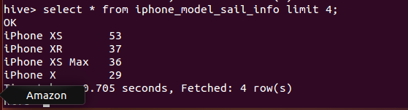

**select type,count(*) hot from saledata where grand like "%Apple%" or grand like "%苹果%" group by type order by type desc limit 20;**

## 3.统计用户各年龄段手机销量

**create table age_region_sail_info(age_region int,model string,count bigint) row format delimited fields terminated by '\t';**

**insert overwrite table age_region_sail_info select u.age_region,s.type,sum(s.views) count from userinfo_new u join evaluation e on u.userid=e.userid join saledata s on s.goodid=e.goodid group by u.age_region,s.type;**

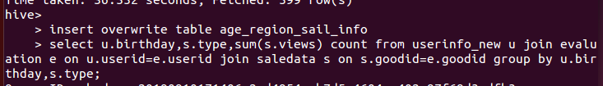

## 4.统计各地区用户手机销量

**create table city_region_sail_info(addr string,model string,count bigint) row format delimited fields terminated by '\t';**

**insert overwrite table city_region_sail_info**

**select u.userlocation,s.type,sum(s.views) count from userinfo_new u join evaluation e on e.userid=u.userid join saledata s on s.goodid=e.goodid group by u.userlocation,s.type;**

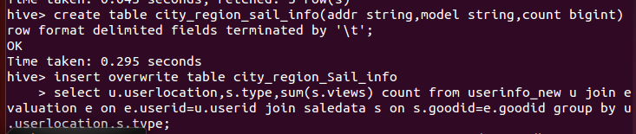

# 实验 4-2 用户行为画像分析

## 新建用户行为权重表

create table act_weight_detail

(

user_id string comment '用户编码',

tag_id string comment '标签 id',

tag_name string comment '标签名称',

cnt int comment '行为次数',

tag_type string comment '标签类型',

act_weight float comment '行为权重'

) comment '用户画像-用户行为标签权重表'

row format delimited fields terminated by '/t';

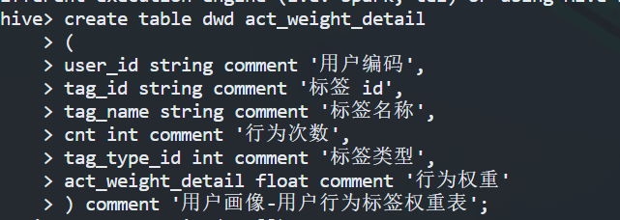

## 2. 创建宽表

create table profile_user_tb

(

user_id string comment '用户编码',

tag_id1 string comment '标签 1 ID',

tag_name1 string comment '标签 1 名称',

tag_type1 string comment '标签 1 类型',

tag_id2 string comment '标签 2 ID',

tag_name2 string comment '标签 2 名称',

tag_type2 string comment '标签 2 类型',

tag_id3 string comment '标签 3 ID',

tag_name3 string comment '标签 3 名称',

tag_type3 string comment '标签 3 类型',

tag_id4 string comment '标签 4 ID',

tag_name4 string comment '标签 4 名称',

action_count bigint comment '标签 4 行为次数',

action_weight decimal(38,7) comment '标签 4 权重',

tag_type4 string comment '标签 4 类型'

) comment '用户画像-用户标签宽表'

row format delimited fields terminated by '/t';

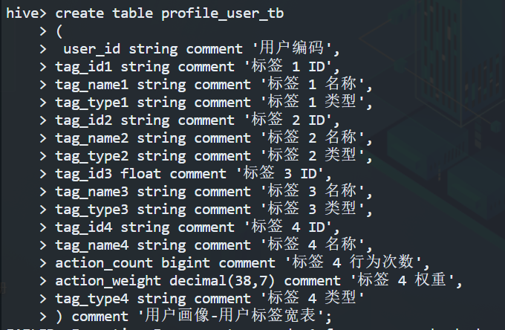

## 3. 插入用户行为权重表

行为类型权重：行为名称：0  权重：1；行为名称：1  权重：2；行为名称：2 权重：3； 行为名称：3  权重：4

Insert into act_weight_detail  select user_id,tag_id,tag_name,action_count

as cnt,tag_type, 1 as act_weight  from profile_tag_action where tag_name='0'

Insert into act_weight_detail  select user_id,tag_id,tag_name,action_count

as cnt,tag_type, 2 as act_weight  from profile_tag_action where tag_name='1'

Insert into act_weight_detail  select user_id,tag_id,tag_name,action_count

as cnt,tag_type, 3 as act_weight  from profile_tag_action where tag_name='2'

Insert into act_weight_detail  select user_id,tag_id,tag_name,action_count

as cnt,tag_type,4 act_weight  from profile_tag_action where tag_name='3'

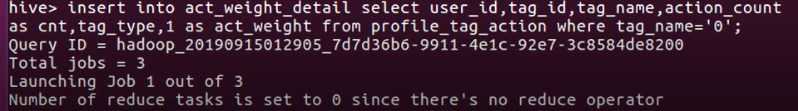

## 4.插入到宽表

TF=（某个标签个数/该用户的所有标签）

行为类型权重：行为名称：0  权重：1；行为名称：1  权重：2；行为名称：2 权重：3；行为名称：3  权重：4

设目前时间为12月31日

时间衰减：当前时间-行为时间即（当前月-月）*30+（当前日-日）

行为次数：从表中查询数据

用户行为标签权重=行为类型权重*时间衰减*TF*行为次数

Temp1保存行为类型权重，时间衰减，行为次数

Temp2保存某个标签个数

Temp3保存用户标签的总个数

Temp4保存用户行为权重

create table temp1(

user_id string,

type_weight int,

time1 int,

action_count int

);

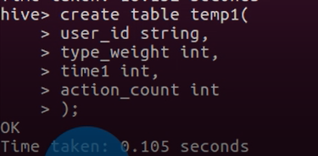

insert into  temp1   select a. user_id  user_id, act_weight type_weight,

(12-b.dealMonth)*30+(31-b.dealDay)  time ,cnt as action_action   from act_weight_detail  a join  useraction b on  a.user_id=b.userid;

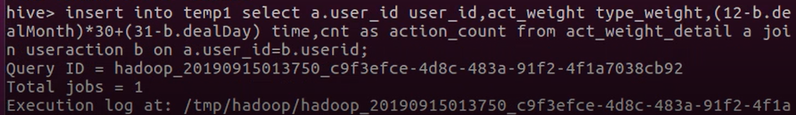

create table temp2(

tag_id string,

tag_count int

);

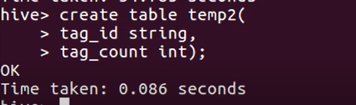

Insert into temp2  select tag_id,sum(*)  tag_count from profile_tag_action

group by  tag_id;

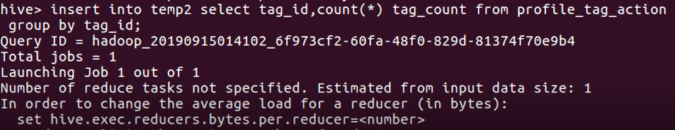

createtable temp3(

user_id string,

tag_sum int

);

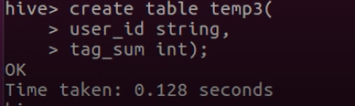

Insert into temp3  select user_id,sum(*) tag_sum  from profile_tag_action

group by user_id;

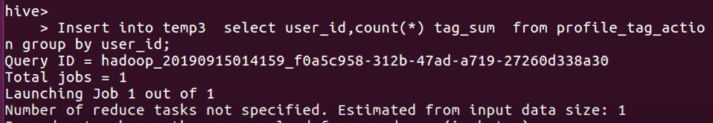

create table temp4(

user_id string,

action_weight  decimal(38,7)

);

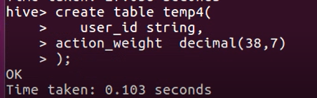

Insert into temp4  Select d.usr_id, d.type_weight*d.time1*( c.tag_count / d.tag_sum )*d.action_count as act_weight_detail  from temp2 c join (select a.type_weight, a.time1,a.action_count,b.tag_sum from temp1 a join temp3 b on a.user_id=b.user_id)  d on d.tag_id=c.tag_id group by d.user_id;

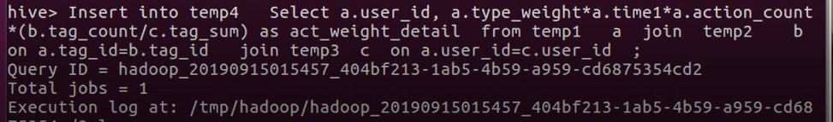

插入宽表语句：

Insert into profile_user_tb

select a.user_id user_id,a.tag_id tag_id1, a.tag_name，tag_name1,a,tag_type tag_type1,b.tag_id tag_id2,b.tag_name

tag_name2,b.tag_type tag_type2,c.tag_id tag_id3,c.tag_name tag_name3,c.tag_type tag_type3,d.tag_id tag_id4,d.tag_name tag_name4,d.cnt action_counte. action_weight  action_weight,d.tag_type tag_type4

from profile_tag_user_gender a

join profile_tag_age_region b on a.user_id=b.user_id

join profile_tag_user_grade c  on a.user_id=c.user_id

join act_weight_detail d on d.user_id=a.user_id

join temp4 e on e.user_id=a.user_id

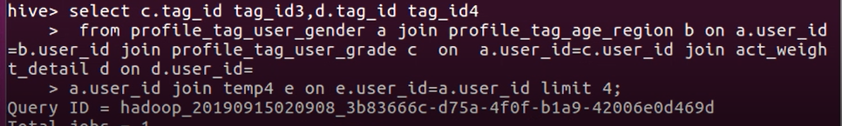

# 实验 4-3 中文分词实现用户评价分析

## 中文分词并统计词频

import jieba

import re

from collections import Counter

cut_words=""

for line in open(r"C:\Users\lenovo\Desktop\互联网精准营销\comment.txt",encoding='utf-8'):#读入文件

    line.strip('\n')

    line = re.sub("[A-Za-z0-9\：\·\—\，\。\“ \”]", "", line)

    seg_list=jieba.cut(line,cut_all=False)#分词

    cut_words+=(" ".join(seg_list))

all_words=cut_words.split()

print(all_words)

c=Counter()

for x in all_words:

    if len(x)>1 and x != '\r\n':

        c[x] += 1

print('\n词频统计结果：')

f2 = open(r"C:\Users\lenovo\Desktop\互联网精准营销\comment_word_count_tb_top200.txt", 'a+',encoding='utf-8')

for (k,v) in c.most_common(200):# 输出词频最高的前两个词

    print("%s:%d"%(k,v))

    f2.write(k)#写入文件

    f2.write(',')

    f2.write(str(v))

    f2.write('\n')

f2.close()

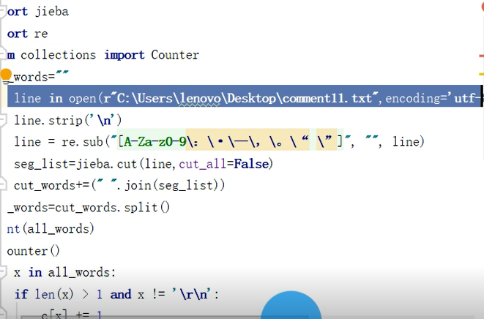

## 创建词频表

create table comment_word_count_tb(

word string,

count int

)

row format delimited fields terminated by '/t';

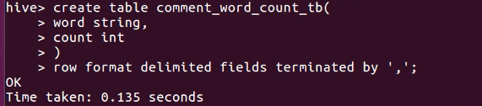

## 导入文件

load data local inpath '/usr/local/comment_word_count_tb_top200.txt' into table comment_word_count_tb;

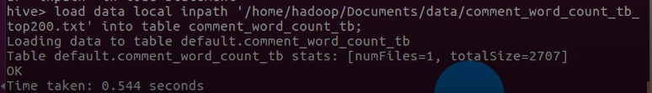

# 实验4-4 Hiveql实现价格时间段销量分析

## 划分时间段统计手机销量

create table date_range_sail_count(date_range string,sail_count int) row format delimited fields terminated by '\t';

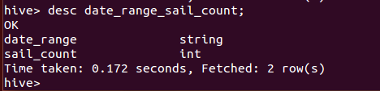

insert overwrite table date_range_sail_count select date_range,sail_count from(select dealtime date_range,count(*) sail_count from useraction_new group by dealtime)t2;

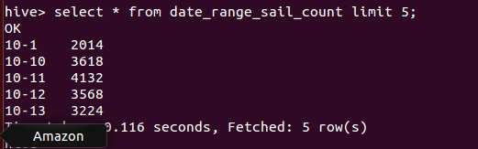

## 划分价格区间统计手机销量

create table price_range_sail_count(price_range string,sail_count int) row format delimited fields terminated by '\t';

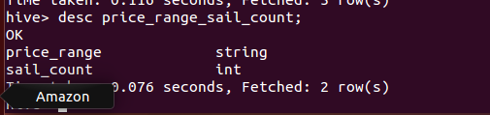

insert into table price_range_sail_count select "1000元以下" as price_range,sail_count from(select sum(views) sail_count from saledata where price<1000)t3;

insert into table price_range_sail_count select "1000-2000元" as price_range,sail_count from(select sum(views) sail_count from saledata where price>1000 and price<2001)t3;

insert into table price_range_sail_count select "2000-3000元" as price_range,sail_count from(select sum(views) sail_count from saledata where price>2000 and price<3001)t3;

insert into table price_range_sail_count select "3000-5000元" as price_range,sail_count from(select sum(views) sail_count from saledata where price>3000 and price<5001)t3;

insert into table price_range_sail_count select "5000-8000元" as price_range,sail_count from(select sum(views) sail_count from saledata where price>5000 and price<8001)t3;

insert into table price_range_sail_count select "8000-10000元" as price_range,sail_count from(select sum(views) sail_count from saledata where price>8000 and price<10001)t3;

insert into table price_range_sail_count select "10000元以上" as price_range,sail_count from(select sum(views) sail_count from saledata where price>10001)t3;

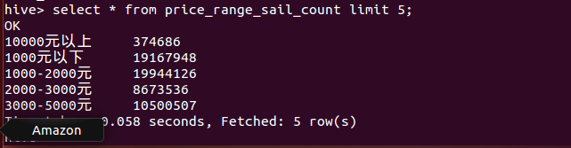

# 实验 4-5 Sqoop 实现分析数据的导出

## 导出文件

导出用户各年龄段销量表数据；

导出各地区手机单品销量数据；

导出手机销量 Top10 表中数据；

导出华为手机单品销量 Top20 数据；

导出苹果手机单品销量 Top20 数据；

导出各时间段手机销量数据；

导出各价格区间手机销量数据；

导出用户评论词频统计 Top200 数据；

Insert overwrite local directory '/usr/local/hive/comment_word_count_tb'

row format delimited fields terminated by '\t' select * from

comment_word_count_tb;



导出用户标签宽表数据；

Insert overwrite local directory '/usr/local/hive/profile_user_tb'

row format delimited fields terminated by '\t' select * from

profile_user_tb;



## 将文件转化成csv文件

（1）将文件用NotePad++打开

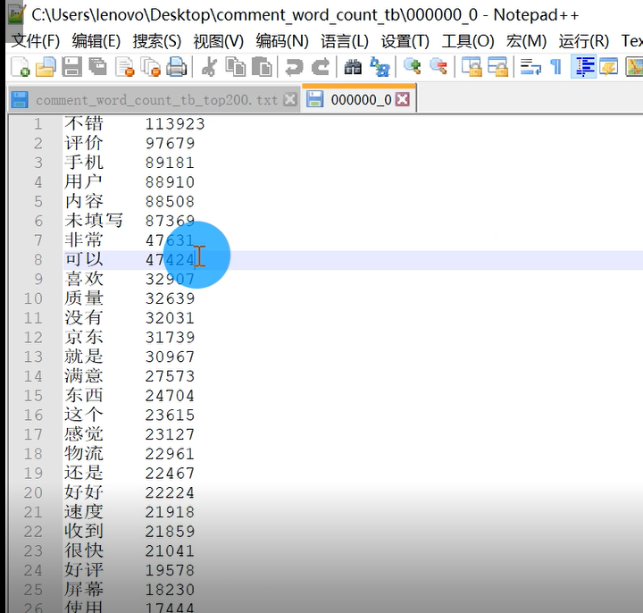

（2）将Tab空格键转化成英文逗号

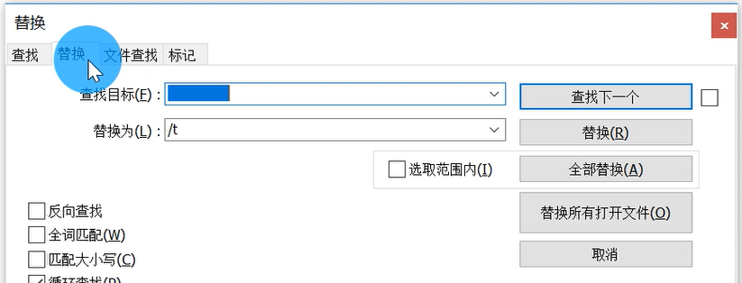

（3）添加列标题

（4）另存为csv文件

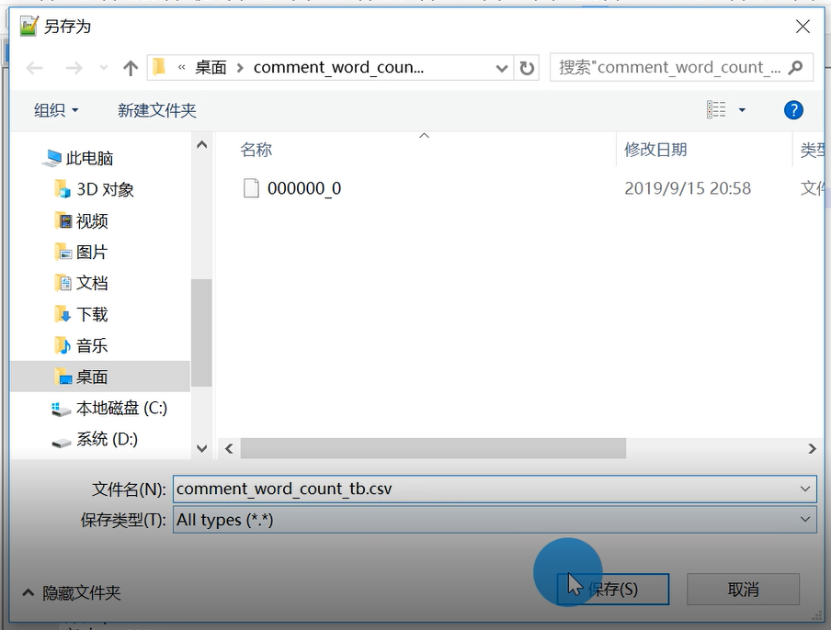

# 实验 5-1 基于 PandaBI 的数据可视化

## 1.将文件导入PanaBi工具中

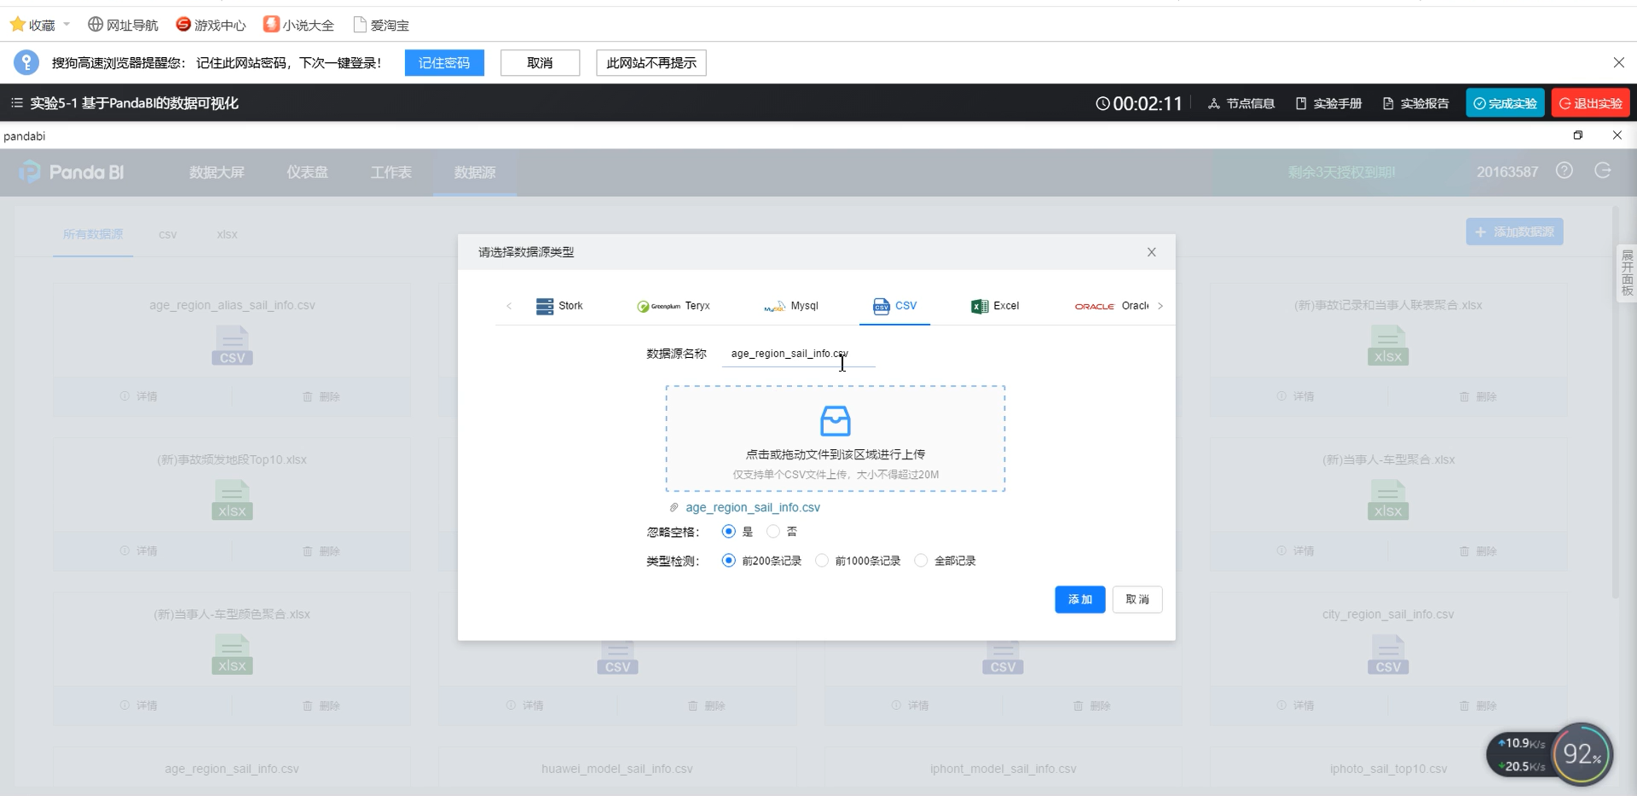

## 2.将文件转化成工作表

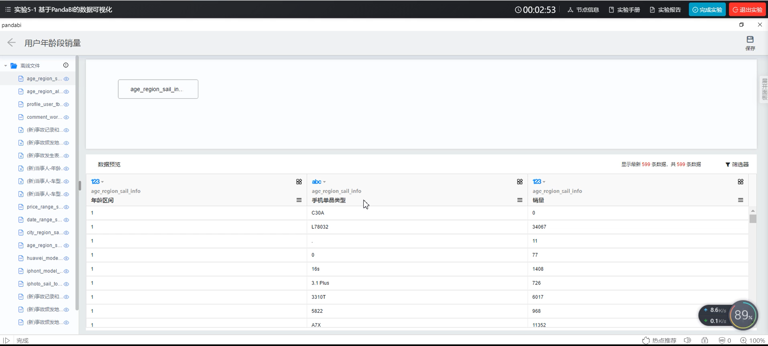

## 根据工作表形成图表

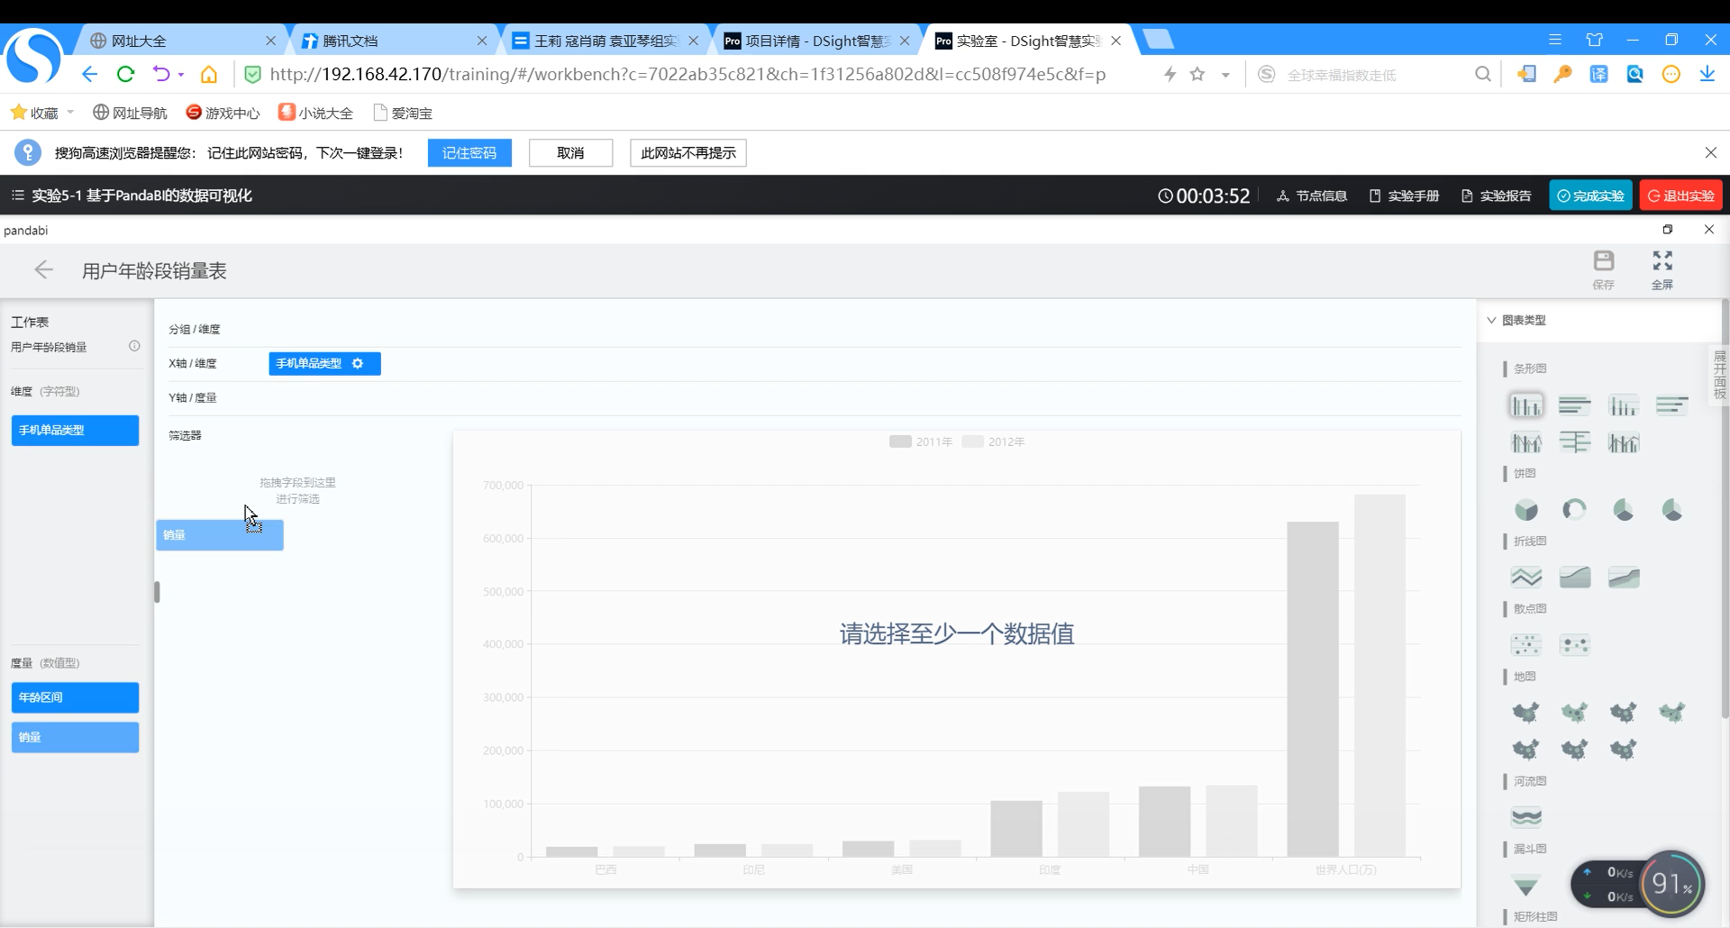

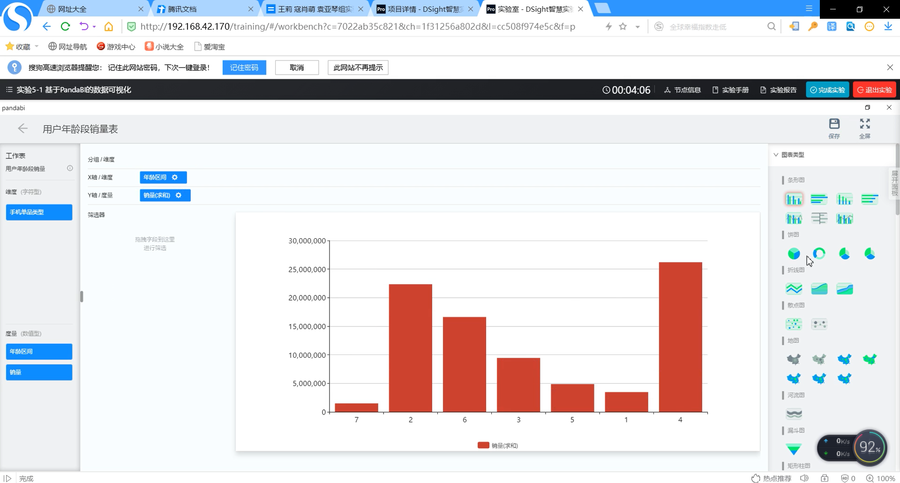

## 4.将图表进行排版形成可视化数据大屏

